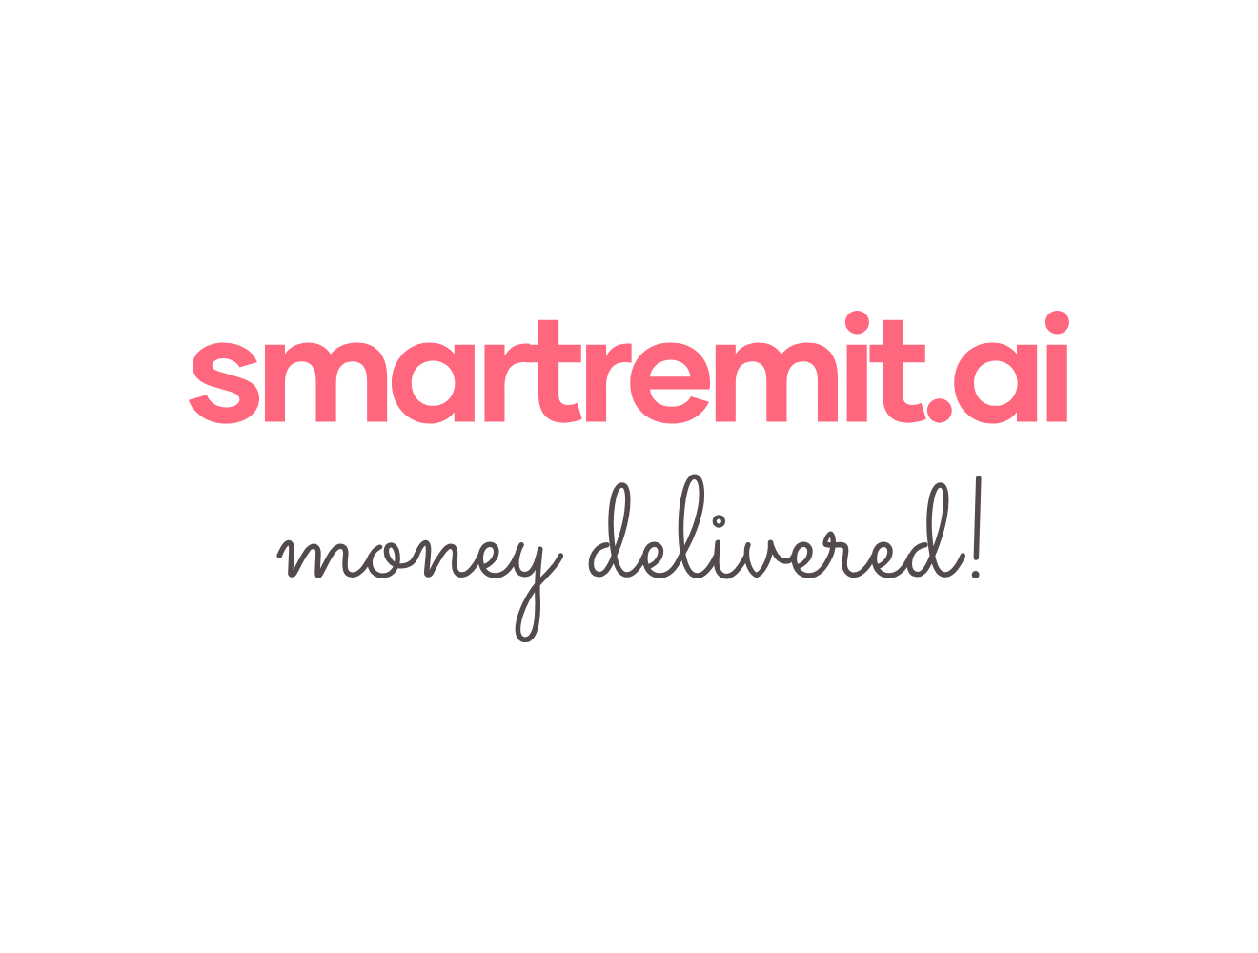

SmartRemit AI Partner Onboarding Playbook
1. Partner Categories
Partner Type | Why It Is Needed | Examples to Research
Sponsor Bank / MSB Partner | Required to legally hold, move, or process USD depending on the operating model. | Evolve Bank & Trust, Cross River, other licensed providers
KYC / AML Provider | Verifies user identity and screens users against watchlists. | Persona, Onfido, Jumio
Bank Linking / Funding Provider | Links US bank accounts and checks account holder details or balance. | Plaid, Finicity, MX
FX / Cross-Border Rails | Provides FX rates, currency conversion, and cross-border transfer capability. | Wise Platform, Nium, Ripple
India Payout Provider | Pays INR to recipients through UPI, IMPS, or bank transfer. | RazorpayX, Cashfree, banks or payout aggregators
WhatsApp Messaging Provider | Connect the product backend with WhatsApp messages. | Meta Cloud API, Twilio
Voice / AI Tools | Supports speech-to-text and conversational parsing in later phases. | OpenAI Whisper, LLM provider, ElevenLabs if voice reply is required

2. Partner Evaluation Checklist
Check | Question to Answer
Regulatory Fit | Are they licensed or suitable for the role they will perform?
Country Coverage | Do they support the required sending and receiving countries?
India Payout Support | Can they support UPI, IMPS, or bank account payout in India?
API Availability | Do they provide clear API documentation and sandbox access?
Settlement Speed | Can they support instant or near-instant payout?
Pricing | What are the setup, transaction, FX, and support costs?
Compliance Support | Do they support KYC, AML, reporting, and audit needs?
Support Model | Do they provide partner support, SLA, and escalation contacts?
Contract Requirements | What documents are needed for onboarding?

3. Partner Onboarding Steps
Step | Action
1 | Create a shortlist for each partner category.
2 | Collect website, API documentation, sales contact, and supported countries.
3 | Check whether the partner supports the first corridor: US to India.
4 | Request sandbox access or demo credentials.
5 | Confirm pricing, licensing assumptions, and compliance requirements.
6 | Share partner findings with product and technical teams for review.
7 | Move selected partners into integration planning.

4. Questions to Ask Partners
• Do you support US to India remittance or payout workflows?
• Do you support UPI and IMPS payout in India?
• Do you provide sandbox access for testing?
• What documents are required to onboard a startup or pilot customer?
• What are your standard fees, FX margins, and settlement timelines?
• What compliance responsibilities remain with us and what do you handle?
• Do you provide webhook notifications for transaction status updates?

5. Launch Corridors

Launch Region | Remittance Currency | Corridor
United States | USD to INR | US to India
United Kingdom | GBP to INR | UK to India
United Arab Emirates | AED to INR | UAE to India
Australia | AUD to INR | Australia to India
Singapore | SGD to INR | Singapore to India
Canada | CAD to INR | Canada to India
New Zealand | NZD to INR | New Zealand to India

6. Partner Directory
Region | Company | Address / Office | Public  Contact
US | Remitly | 1111 3rd Ave., 21st Floor, Seattle, WA 98101, USA | -
UK | Paysend | 1st floor, 20 Garrick St, London WC2E 9BT, United Kingdom | -
UAE | Al Ansari Exchange | Level 7, Al Ansari Business Center, Al Barsha 1, P.O.Box 6176, Dubai, UAE. | -
Australia | OFX | Level 19, 60 Margaret Street, Sydney, NSW 2000, Australia | -
Canada | Xe | 56 Temperance Street, Suite 801, Toronto, Ontario, M5H 3V5, Canada. | -
New Zealand | WorldRemit | 41 Shortland Street, Auckland CBD, Auckland 1010, New Zealand. | -
US | Xoom | PayPal Global Headquarters  2211 North First Street  San Jose, California 95131 | -
US | Ria Money Transfer | 7000 Village Dr, Suite 200, Buena Park, CA 90621 | -
UK | Wise | Worship Square, Shoreditch, London, United Kingdom | -
US | Western Union | 7001 E. Belleview  Denver, CO 80237 | -
US | MoneyGram | 2828 N. Harwood St., 15th Floor, Dallas, TX 75201, | -
UK | Sendwave | 167-169 Great Portland Street, 5th Floor, London, W1W 5PF, United Kingdom | -
Singapore | Instarem / Nium | 168 Robinson Road, #18-03, Capital Tower, Singapore 068912 [ | -
Singapore | SingX | 138 Cecil St, By Appointment Only, Singapore 069538 | -
New Zealand | OrbitRemit | Floor 1, 182 Vivian Street  Te Aro, Wellington, 6011  New Zealand | -
UAE | LuLu Exchange | Community - Level 9, Bays Water Tower - Burj Khalifa St - Business Bay - Dubai | -
Canada | RemitBee | 107 Dundas St E, Mississauga, ON L5A 1W7, Canada | -

